Max length:

Name: uppercase letter A-Z, if enter lowercase in LoanPlus will display Uppercase

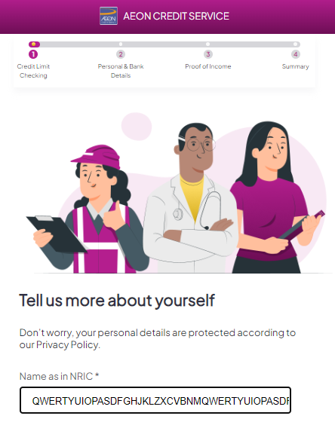

Character + special characters:

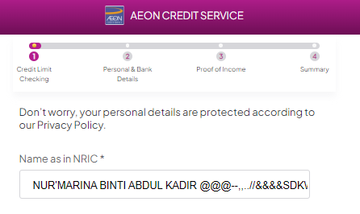

Email: character + number + special character

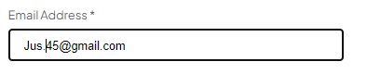

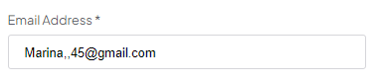

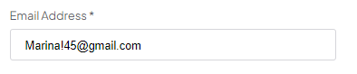

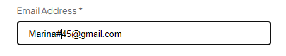

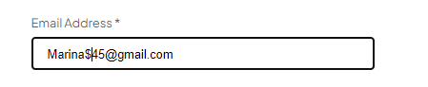

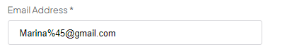

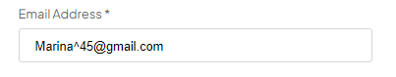

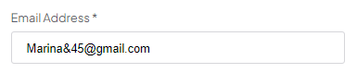

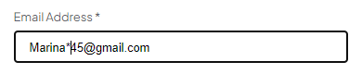

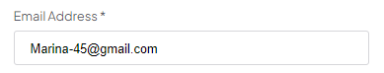

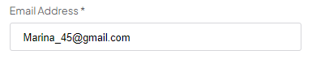

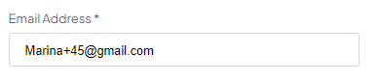

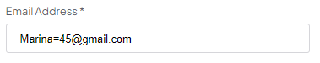

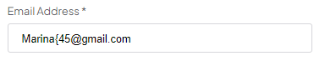

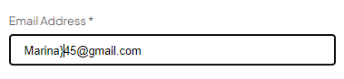

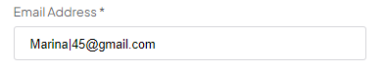

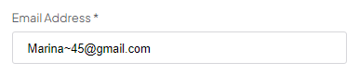

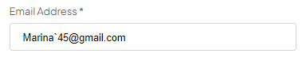

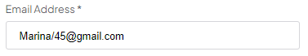

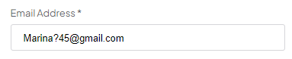

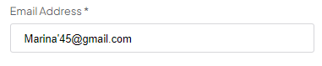

Address:  
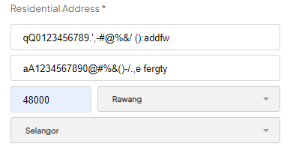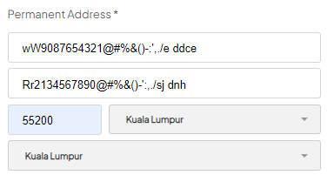

Immediate family or relative name:  
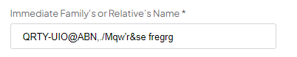

Company name:

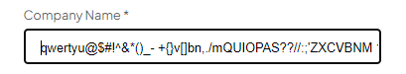

Company Address:

